**Technical Description of Western Saddles**

Starlan Davis

Technical Writing

Kennesaw State University

Professor D. Measel

June 27, 2025

*Exercise 7.2 Template*

|  |  |
| --- | --- |
| **Audience and Purpose** | Who will read this description and why? |
| **Definition and Function** | What is it? What does it do? What is its function/purpose? |
| **Overview** | Describe its overall appearance (shape, size, color, etc.). |
| **Components and Explanations** | Describe the component parts (chose the most relevant features) and explain how they work together; try to find the most logical way to organize this explanation. |
| **Visuals** | What kind of illustrative graphics will you use? Where?   * Diagrams * Photographs * Cut-away views * Exploded views |
| **Conclusion** | Do you need to offer any further information? History? Warnings? Context? Costs? etc. |
| **References** | Any sources used, or supplemental sources to suggest. |

*Table of Exercise 7.2 Filled Out*

|  |  |
| --- | --- |
| **Audience and Purpose** | Equestrians and new horse riders would read this to better understand how the saddle functions and protects them and their horse during rides. They could also read this to ensure they know how to choose an appropriate saddle. |
| **Definition and Function** | Western Saddle  -- Saddles provide a horse rider with comfort and security and promote injury prevention to the horse’s back. |
| **Overview** | Western saddles are most obviously identified by the horn located at the front. Seat sizes range from about 14 to 16 inches |
| **Components and Explanations** | * Saddle Tree – The base of the saddle. Typically made of wood or synthetic materials. * Gullet – The area between the front and back of the saddle. The recommended size differs depending on the width of the specific horse’s back. Designed to allow movement of the horse’s spine and withers (shoulders). * Cantle – The back of the saddle; it is higher than other parts of the saddle. This part provides protection to the rider’s back and supports remaining in a safe and comfortable position. * Stirrups – Provide the rider with balance and support. Typically made of metal or leather; the size varies depending on the rider. * Horn – Protrudes from the front of the saddle. Can be used as a handhold when mounting or dismounting, and as an anchor for tying objects (ropes, reins, etc.). |
| **Visuals** | Medium: Photographs   * Side view * Close-up of the stirrups * Close-up of the gullet |
| **Conclusion** | I could include information about the history and costs. |
| **References** | [A Comprehensive Guide to the Parts of a Western Saddle | SouthwesternEquine](https://southwesternequine.com/blogs/educational/a-comprehensive-guide-to-the-parts-of-a-western-saddle)  [Guide to Western Saddles for Horses: History, Types & Construction | Mad Barn](https://madbarn.com/western-saddles-for-horses/?srsltid=AfmBOorTX22CFbfdQy5J8kiMVLneBh4mrirI5pGynCXW4Aw9JlIZpHu0&utm_source=chatgpt.com#westernsaddle) |

Figure 1

*Ranch Saddles*

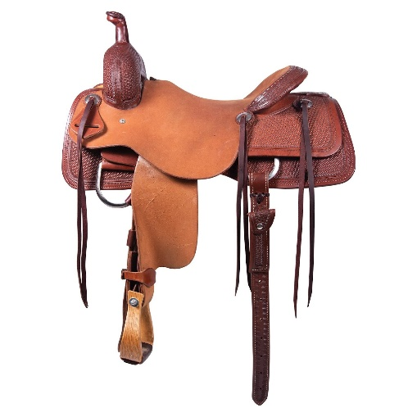 *Note.* From "Types of Saddles: All Types of Western and English Saddles," by Healthy Horse Help, n.d. (https://healthyhorsehelp.com/blog/types-of-saddles-all-types-of-western-and-english-saddles/). Copyright © Healthy Horse Help.

Figure 2

*Gullet of a Western Saddle*

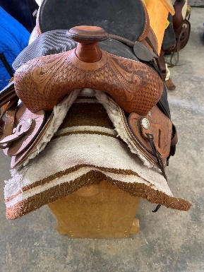 *Note. Reprinted from “Western riding saddle – Texas USA maker…” by Live Auction World, 2024 (Copyright © 2025 Live Auction World).*

Figure 3

*Saddle Stirrups*

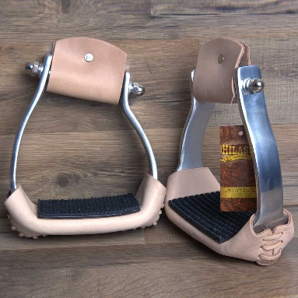 *Note*. Adapted from product image on Walmart (or Hilason) website. Copyright 2025 by Hilason.

Modern-day western saddles developed from the working saddles of Spanish Vaqueros who used these saddles when working cattle.A western saddle is a style of saddle designed for function and promotion of the comfort and safety of the horse and rider. This is seen throughout the anatomy of the saddle. For example, the horn, a western saddle’s most unique feature, is a valuable tool for securing roped livestock. In addition to the saddle’s horn; the stirrups provide the rider with back and spinal support by helping the rider to maintain proper posture; the gullet, the area between the front and backends of the saddle, ensures that the horse maintains full range of motion by allowing for space for the spine and withers; and the skirts, leather or suede that hang from the sides of the seat, help to reduce the pressure on the horse’s back, as well as aid in keeping the rider in place on the saddle.